**Multi-Touch Attribution Analysis - Entertainment Sector**

Pooja Joshi & E.Code [E25007]

# Overview :

# The main goal of today's tasks is to conduct a Multi-Touch Attribution (MTA) analysis for movies in the entertainment sector. This involves analyzing how different marketing channels impact movie performance and developing actionable strategies based on the results.

# Objective:

* Analyze attribution results from simulated data.
* Visualize the attribution scores using appropriate charts.
* Identify insights and propose recommendations for future marketing strategies.

# Assigned Task(s) :

**Task 1: Analyze Attribution Results**

* **Status**: Completed
* **Details**:
  + Analyzed the attribution scores for various movies using three different models: linear, time decay, and position-based attribution.
  + Identified movies with the highest attribution scores for each model.

**Task 2: Visualize Attribution Results**

* **Status**: Completed
* **Details**:
  + Created visualizations (bar plots) to represent the attribution scores of the movies.
  + Generated visual insights for easier interpretation of how different movies performed across attribution models.
  + Ensured that visualizations clearly displayed the differences in attribution scores among top movies.

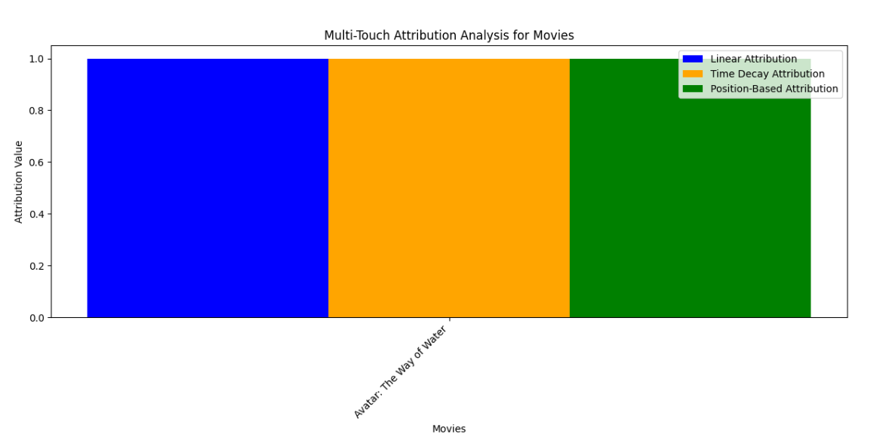

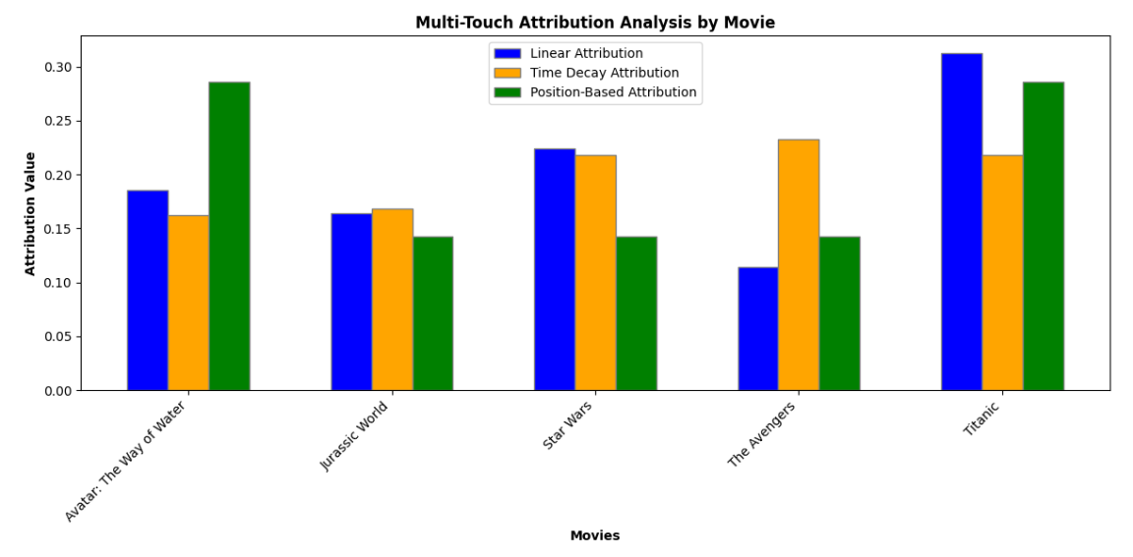

**Task 3: Identify Factors Influencing Attribution Scores**

* **Status**: Completed
* **Details**:
  + Analyzed the attribution scores to understand which movies are receiving the highest scores.
  + Investigated potential factors influencing performance, such as popularity, attendance, and sentiment.
  + Compiled insights for discussion on why certain movies may have outperformed others.

# 

**Progress :**

**Accomplishments**

* Successfully visualized attribution results to facilitate easier interpretation.
* Identified the top-performing movies based on attribution scores.

**Metrics**

* Top movie by linear attribution: **Titanic** with a score of **0.3128**.
* Top movie by time decay attribution: **The Avengers** with a score of **0.2329**.
* Top movie by position-based attribution: **Avatar: The Way of Water** with a score of **0.2857**.

# Challenges and Solutions :

**Challenges Faced**

* Encountered KeyError due to missing columns in the attribution results, hindering further analysis.

**Solutions Implemented**

* Identified the available columns in the attribution results and adjusted the analysis to focus only on the available data.

# Next Steps :

**Upcoming Tasks**

* Gather additional data related to user interactions, marketing efforts, and demographics.
* Refine attribution models and experiment with more complex approaches.

**Goals**

* Set clear objectives for improving the analysis by integrating new data and refining the attribution methodologies.

# Conclusion :

# Summary: Today's analysis of Multi-Touch Attribution for movies in the entertainment sector provided valuable insights into the effectiveness of various marketing strategies. Moving forward, the integration of additional data and refined models will enhance the robustness of the analysis.

# **Acknowledgments**: Thank the audience for their time and attention.

# Instructions:

1. Use Google Docs. Single Column
2. TNR stands for Times New Roman: B - Bold
3. Use images as required with proper references
4. Use charts, tables as per your requirement.
5. Number of Pages: 2 to 8 for each task report.